The Digispark runs the “micronucleus tiny85” bootloader version 1.02, an open source project: [https://github.com/micronucleus/micronucleus] originally written by Bluebie: [https://github.com/Bluebie].

The bootloader is the code that is pre-programmed on your Digispark and allows it to act as a USB device so that it can be programmed by the Arduino IDE (the Digispark uses the Arduino IDE 1.6.5+).

**Pin Headers: along with attiny mcu…9 pins..break 6 and 3…can solder on mcu…**

**1. 6 GPIO pins:**

Pin outs:

* All pins can be used as Digital I/O
* Pin 0 → I2C SDA, PWM (LED on Model B…near Pin0)
* Pin 1 → PWM (LED on Model A..near Pin 3)
* Pin 2 → I2C SCK, Analog In
* Pin 3 → Analog In (also used for USB+ when USB is in use)
* Pin 4 → PWM, Analog (also used for USB- when USB is in use)
* Pin 5 → Analog In

**2. LEDs :**

Power LED near P0

Status LED near P3(connected to Pin 1)

**3. Voltage Regulator:**

**VR:**  
Regulates 6-16V to 5V and supplies to ATTINY85 and 5V power output.

**3 Pins:**

Input Voltage(Vin) = If power not supplied through USB…It can be supplied from here after soldering..

Ground

5V

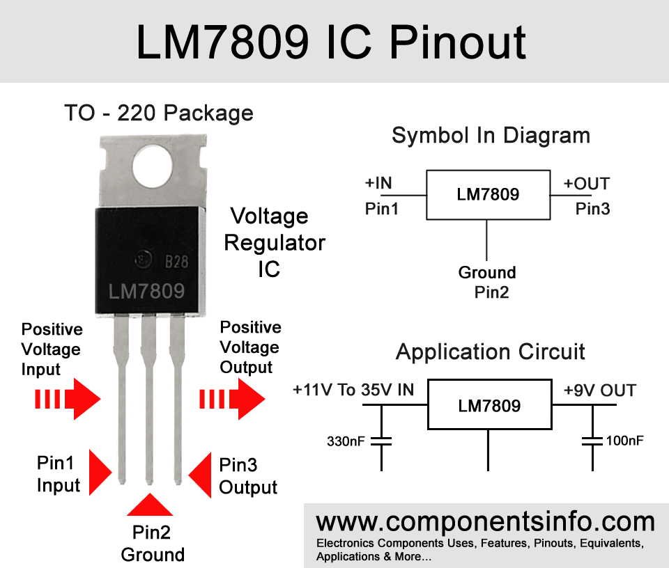

**4. ATtiny(MCU version)8(8KB ISP flash memory)5 microprocessor**

The ATtiny85 is a RISC (Reduced Instruction Set Computer) based processor  
Still part of the AVR family  
Among popular processors used in Arduino Boards  
Contains USI (universal serial interface)

Type of IC = AVR microcontroller

Use on-chip flash memory for program storage, as opposed to one-time programmable ROM, EPROM, or EEPROM used by other microcontrollers at the time

Flash, EEPROM, and SRAM are all integrated onto a single chip, removing the need for external memory in most applications.

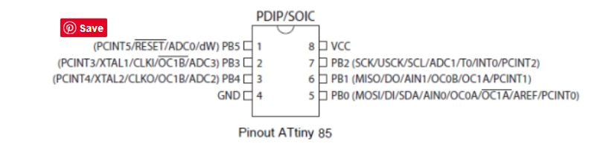

VCC (Voltage Common Collector) is the higher voltage with respect to GND (ground). VCC is the power input of a device. It may be positive or negative with respect to GND.